Link Quality Estimation for Industrial Wireless Sensor Network using Burstiness Distribution Metric
Ngoc-Huy NGUYEN¹ and Myung-Kyun KIM¹
¹ University of Ulsan, 44610 Daehak-ro 93, Nam-gu Ulsan, South Korea
{huynguyen.haui1412@gmail.com, mkkim@ulsan.ac.kr}
Abstract. As the mature of Industrial Wireless Sensor Network applications are increasingly requiring about low-power operations, deterministic communications, and end-to-end reliability. It is very difficult to achieve this goal because of link burstiness and interference. In this paper, we propose a novel link quality estimation metric namely Burstiness Distribution which uses the distribution of burstiness in the link to deal with the variations in the link quality of Wireless Sensor Networks. First, we estimate the link quality by count the number of consecutive loss packet happenings in each bi-direction link using the sequence number of Probe Packet received in the receiver node. Then we have the Burstiness Distribution List for each bi-direction link. Based on that the node can decide to choose the best route for the routing and estimate the number of retransmission to reach the reliability in the scheduling algorithm. Our experiment shows that the Burstiness Distribution metric can be used as the input metric to choose the minimal retransmission path for the routing protocol and calculate the number of retransmission in scheduling to achieve the target for the latency and reliability in Industrial Wireless Sensor Network.
Keywords: IEEE 802.15.4e, Industrial Wireless Sensor Networks, Link Metric Measurements, Link Burstiness, Reliability.
- INTRODUCTION
Wireless Sensor Networks (WSN) are used to monitor and control systems in the industrial area and have some advantages such as low cost and high flexibility when compared with the use of wired networks. Some applications were proposed such as monitoring applications, radiation checks, leakage detection, distributed, and process control. Industrial low-power wireless mesh network applications have strong requirements in terms of latency, energy efficiency, and reliability. The end-to-end delay is constrained by upper bounds which varies according to the field of application. These critical requirements for the efficient operations of the networks are the identification and use the high-quality links. IEEE 802.15.4-TSCH (Time-Slotted Channel Hoping) aims at providing high-level network reliability by keep nodes time-synchronized and employing a channel hopping approach.
Moreover, routing in multi-hop low power networks such as RPL, LOADng, LRP has the target to seek effective routes. These protocols have to keep their own foot-print small while selecting the best way to route the data traffic. So this preliminary link quality measurement needs to be precise and accurate for the routing to succeed. However, the highly non-deterministic of the wireless links is a challenge because of electromagnetic interference, and high attenuation, due to the presence of obstacles. It is necessary to deal with typical problems of wireless networks: burstiness link and interference. The interference link is the physical property of the environment that causes the packet transmission between different links to interfere with each other. Burstiness link is another physical property that means transmissions of the wireless link do not have a fixed probability of failure; it has periods of continuous loss packet. Due to these non-deterministic wireless links, it is difficult to offer reliability for packet transmit over the wireless networks.
Srinivasan et al. presented a new metric called β to measure the link burstiness. The authors have shown that we can avoid link burstiness by having an inter-packet delay of 500 ms.[P2]. [P2] proposes a scheduling algorithm that provides delay guarantees for the periodic real-time flows considering both link bursts and interference. A new metric called maximum burst length (Bmax) is defined as the maximum length of error burst, estimated by using empirical data. The algorithm then provides a reliability guarantee by allocating each link one plus its corresponding maximum burst length time slots. the novel least-burst-route algorithm is used in conjunction with this scheduling algorithm to minimize the sum of worst-case burst lengths over all links in the route.[P11]. However, the algorithm to calculate Bmax value is gathered from the experiment measure link with the long sequence of data-trace before settings the network. It makes this algorithm hard to apply for the ad-hoc network. And the use of Bmax is the maximum retransmission is overestimation for some kind of network.
This paper proposes a novel link quality estimation metric calculated by the distribution of burstiness in the link. Burstiness distribution can be calculated by using the Probe Packet during the bootstrapping phase. We argue that when a node ranks its neighbors through their rate of Probe packets received, it can identify a stable parent. Our experiments on the Contiki-NG OS platform highlight that our approach improves the reliable target and identifying the best routes to the border router. The use of Burstiness distribution metric can easy to apply for the ad-hoc network and become metric for Routing Protocol to find the stable parent and for Scheduling Protocol to estimate the number of retransmission to reach the reliable target for specific application [P3]
- BACKGROUND AND RELATED WORK
Some Link Quality Estimators are based on information from the physical layer (hardware-based), such as the Received Signal Strength Indicator (RSSI) and the Link Quality Indicator (LQI), and others are based on upper layers information (software-based), such as the Packet Reception Rate (PRR), Expected Transmission Count (ETX). RSSI is a terminology used to describe a measurement of the power present in a received radio signal. RSSI is measured at the radio chip on the base station. LQI is based on signal-to-noise ratio in the frequency band and provides average correlation values for each received packet.[P4]
For Industrial Wireless Sensor Network the Link Quality Estimator needs to be accurate, and stable to avoid switch the channel or the route due to small and rapid variations, which would cause a high delay. Besides the estimator needs to rapidly identify abrupt and persistent changes in the channel characteristics. The burstiness distribution metric proposed in this paper tries to satisfy these requirements [P1].
  - Hardware-based Estimators
The hardware-based estimators do not require computational resources from the sensor nodes, since the metric values are provided by the transceiver. However, using only the information provided by hardware-based estimators directly may not be sufficient, therefore some processing should be performed to extract useful information. Each packet received by the IEEE 802.15.4 radios has values of RSSI and LQI associated with it. However, RSSI can be obtained regardless of the reception of a packet. Any device that generates interference in the frequency range of the channel can influence the RSSI value. The LQI can only be measured during the reception of a packet since the measurement is based on the analysis of the initial symbols of the received packets. Thus, when the network experiences a high Packet Error Rate (PER), this metric can overestimate the link quality, since it does not consider the lost packets. Besides, as the implementation of LQI is vendor-specific, it is difficult to develop a general solution using this metric. Raw values or averaged values of small samples of RSSI have a low correlation with the PRR in very reflective environments, due to the random variation of the energy level in such environments [P1]. Some works used the RSSI or LQI to estimate the channel quality.
Noda et al. proposed two metrics to assess the quality of the channel based on channel vacancies. Although this metric can identify channels that are less affected by sources of impulsive noise, it may also present problems to estimate the channel quality in the presence of multipath fading. Zacharias et al. proposed an algorithm to identify the presence of Wi-Fi networks, Bluetooth networks, or microwave ovens, using RSSI samples. The analysis is based on the periodicity of interference sources. It also considers only interference problems[P1].
Jindong et al. proposed a metric to estimate the channel quality using RSSI and LQI. This metric showed a good correlation with the PER in experiments and a smaller variance in comparison with the use of the only RSSI in our LQI. In the presence of sources of interference and multipath, this approach may provide erroneous results, since it uses raw values obtained from received packets.
Bildea et al. studied the correlation between RSSI, LQI, and PRR. The RSSI was not a very accurate estimator of PRR in the experiments. Thus, the work has focused on the utilization of LQI. However, the metrics based on LQI may overestimate the channel quality in scenarios with impulsive noise, since the LQI of lost packets is not considered.
Eskola et al. proposed a classifier to identify disturbances in the wireless channel, which is capable to identify if a channel has line-of-sight or not and if there is external interference. However, the proposed technique is only capable of identifying the existence of disturbances but does not provide any metric, that could be used by protocols to dynamically optimize the network performance. Besides, the analysis is made in the modulation level, using a software-defined radio, which is impractical to be done with off-the-shelf WSN radios [P1].
Gomes et al. propose to introduce LQE nodes dedicated to traffic monitoring and link quality estimation. Typically, LQE nodes are all the nodes which have to forward traffic. They use the RSSI and LQI values to infer the Packet Delivery Ratio (PDR) of the given links. Unfortunately, RSSI and PRR have been proved to be only loosely correlated in many situations[P3].
  - Software-based Estimators
The software-based estimators use information obtained from upper layers, such as the PRR, and the Required Number of Packet Transmissions (RNP). The use of metrics based on PRR allows a good estimation for links with very high or very low quality, but present some problems in intermediate links. When retransmission is used, the metrics based on PRR overestimate the link quality, since they do not consider the number of transmission attempts before a successful reception. The metrics based on RNP estimate the required number of packet transmissions until a successful reception. The Expected Transmission Count (ETX) and Four-Bit (FB) are examples of RNP-based estimators.
The ETX is a receiver-initiated estimator, which considers link asymmetry by estimating the PRR in both directions by using the PRR of the backward link, and the PRR of the forward link. Probe broadcast packets are used to calculate the PRR of the backward link and the PRR of the forward link. The [] show the correlation between ETX, RSSI, and LQI for an indoor office environment, and outdoor environments, using raw values of RSSI and LQI. In the experiments, no significant correlation was found between the metrics. As discussed in Section 2.1, the raw values of RSSI and LQI are not sufficient to properly estimate the link quality. The two LQE strategies (one passive and one active) implemented in the IPv6 Routing Protocol for Low power and Lossy Networks (RPL) were evaluated in [34]. When using active estimation, probe packets are sent to calculate the ETX. In the experiments described in [34], the performance of the estimator was better when using active estimation. However, this approach imposes an overhead in the sensor nodes and on the network[P1].
4-Bit Link estimation mixes active (probe packets) and passive (ETX for data packets) criteria [22] so that probes are only used when no data packet is exchanged with a given neighbor. Probes are broadcast to mutualize the overhead: one single probe helps to refine the link quality toward all the neighbors[P3].
- PROBLEM DEFINITION
Given the fixed number of periodic nodes generated sensor data in the network N = {N₁, N₂, N₃,…, N_{n}} with N₁ is the PAN Coordinator and N₂ to Nn is the set of sensor nodes. We assume nodes are stationary and deployed randomly. In the Network Construction Period(NCP), we define the Joining Period(JP) and Measure Link Quality Period(MLQP) /*need picture*/. We use the advantage of Orchestra's dedicated schedule based on the fixed number of nodes in the network to make the collision-free in NCP. Orchestra [P6] is an autonomous scheduling mechanism where each node independently decides its schedule based on Orchestra Rules.
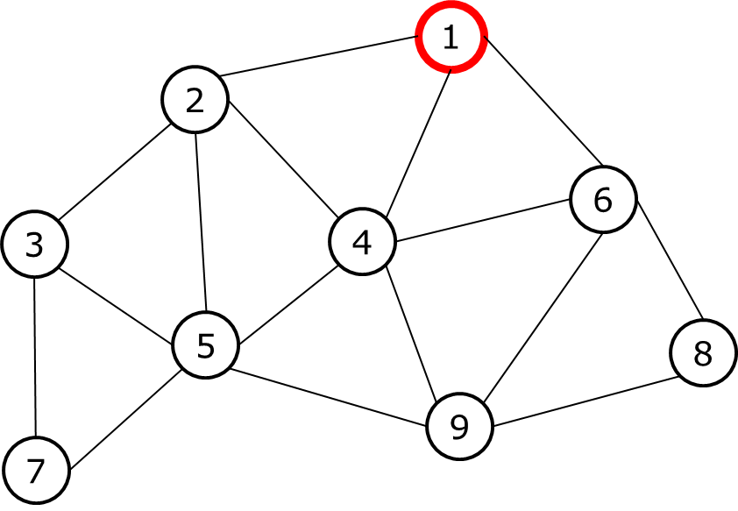
Figure 1. An example network topology.

For example, we consider the network topology as shown in Figure 1. If the two nodes are in the radio range of each other, they are connected by an edge. In the Joining Period(JP), each node autonomous assigns Tx timeslot in its Node-ID and Rx timeslot in all the other timeslots. We use the same channel for this period. /*The PAN Coordinator node start NCP by sending */The Enhanced Beacon(EB), all the sensor nodes are in the scanning mode. If any sensor node received the EB packet, it will synchronize with the network and become a broadcaster node to transmit the EB packet to expand the network. The EB packet is created and sent by the joined nodes in each slot frame.

Table 1. Orchestra Schedule MLQP.

Node | Timeslot | 1 | 2 | 3 | 4 | 5 | 6 | 7 | 8 | 9
1 |  | Tx | Rx |  | Rx |  | Rx
2 |  | Rx | Tx | Rx | Rx | Rx
3 |  |  | Rx | Tx |  | Rx |  | Rx
4 |  | Rx | Rx |  | Tx | Rx | Rx |  |  | Rx
5 |  |  | Rx | Rx | Rx | Tx |  | Rx |  | Rx
6 |  | Rx |  |  | Rx |  | Tx |  | Rx | Rx
7 |  |  |  | Rx |  | Rx |  | Tx
8 |  |  |  |  |  |  | Rx |  | Tx | Rx
9 |  |  |  |  | Rx | Rx | Rx |  | Rx | Tx

After the Joining Period(JP), we switch all the nodes to Measure Link Quality Period(MLQP) and update the Orchestra schedule by removing Rx of the timeslot which doesn’t have any neighbor nodes. The Orchestra schedule for this example is shown inTable 1. The number of Probe Packet has been predefined as NUMBER_OF_PROBE. Each node creates Probe Packet(id, sequence) where id is its node id and sequence is a sequence of Probe Packetand broadcast based on Orchestra timeslot in each slot frame until it reaches the NUMBER_OF_PROBE. If the node receiving the Probe Packet, by using the sequence number, the node will count the number of consecutive loss pack-et by each sender node then add to the Burstiness Distribution List. For example, Node 1 received Probe Packet from Node 4 with the sequence number is 15, denoted by P(4, 15). The next received Probe Packet from Node 4 is P(4, 18). It means that there are 2 consecutive losses happen in sequence number 16 and 17 from Node 3. For each pair of connected node Ni and Nj, we have the link L(i,j) /** define what L(I,j)*/ has the Burstiness Distribution List. Example with link L(1, 4) has PRR 70%, we have Burstiness Distribution List as shown in Table 2 with the count of consecutive loss. In this example, the NUMBER_OF_PROBE is set to 5000 packets.
Table 2. Burstiness Distribution List of link L(1, 4) in MLQP.
Consecutive Loss | 0 | 1 | 2 | 3 | 4 | 5 | 6
L(1, 4) | 2509 | 705 | 223 | 68 | 18 | 7 | 1

To identify the good link to construct the efficient routes,
- EVALUATION
- CONCLUSION

References

